**< SMART BILLING SYSTEM FOR WATER SUPPLY >**

| Name | Roll No./ID | UG/PG | Course/Branch | Semester |
| --- | --- | --- | --- | --- |
| **JAASEEM SALEEM** | 814720104018 | UG | CSE | 6 |
| **JENI PRIYA** | 814720104022 | UG | CSE’ | 6 |
| **JEEVAMUGI** | 814720104021 | UG | CSE | 6 |
| **DHANUSH** | 814720106023 | UG | ECE | 6 |

**Mandatory Supporting Document [to be added along with proposal]**

**Project Abstract**

The advancement in the technology has enable to rule out the probability of *“impossible tasks”.* We being the students of Computer Science, felt that we can address the issue of water we see around in the metropolitan cities. That is when the idea of this project was born.

The main needs to smart system are the increasing Non-Revenue Water, less revenue generated by current system and the interstate dispute for water.

In this project we use the water sensors readily available to log water usage of a particular house, right from drinking purpose, bathing, gardening to *wasting*. This data is used for billing the house owner with different rates for different purposes where ***drinking purpose***being the lowest and ***miscellaneous*** being the highest charged. This increases the revenue generated without being a burden the house owner. Also we are going to integrate the payment with the bank database for ease. 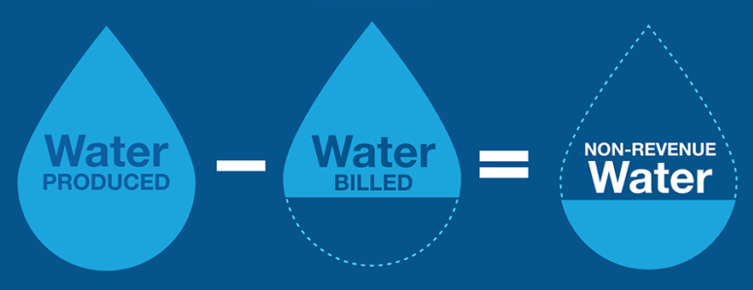

Further, we plan to display real-time statistics to the house owner if required later on in the project.

The main customers for our product will be the government/ government bodies supplying water to public in our whole country like of Bengaluru, Chennai, Mumbai, Delhi, Kolkata etc. But at the beginning stage, we have restricted ourselves to design this product specifically for our beloved city Bengaluru. The BWSSB (Bengaluru Water Supply and Sewage Board) is the target customer at the current. If BWSSB is ready to accept our *smart billing system****,*** we would be very happy to set it up.

**Team Members – Roles & Responsibilities**

| **Sl No** | **Student** |  | **Justification** |
| --- | --- | --- | --- |
|  | **Member** |  |  |
|  | **Name** | **Role** |  |
|  |  |  |  |
| 1 | SJAASEEM SALEEM | DEVELOPER & MARKETING | Coding freak & market enthusiast |
| 2 | JENI PRIYA | DEVELOPER | Interested in new technology |
| 3 | JEEVAMUGI | TESTER | Interested in debugging. |
| 4 | DHANUSH | DESIGNER | Well versed with electronic components and electrical systems |
|  |  |  |  |

**Market Analysis**

1. **Customer Need Identification**

Our customer on the first layer is the *BWSSB (Bangalore Water Supply and Sewage Board)*. Then the second layer customer are the *people building new houses in Bangalore*. Subsequently, we are also extending this project/product to other Smart Cities as applicable.

*The main need of this project is the preservation of water and increasing the revenue of the public water supply bodies.* The following are the main causes for our project to be implemented:

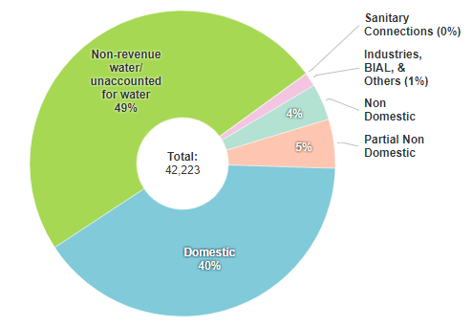

* According to the data given by the BWSSB [1], nearly 49% of the total Kaveri water in Bengaluru is un-accounted or wasted. This accounts for huge loss in natural resource as well as a big loss to the revenue that could be generated by that amount of money.

1. **Serviceable Addressable Market (SAM) Identification & Justification**

* The Total Addressable Market (*TAM*) for our product as mentioned in abstract are government/ government bodies supplying water to public in our whole country like of Bengaluru, Chennai, Mumbai, Delhi, Kolkata etc.
* At the very beginning of the project we are targeting the silicon city of India, Bengaluru. The main reason behind this would be the interstate dispute between Karnataka and Tamil Nadu [3] causes a lot of distress in both the states. So if we could account for the water usage in Bengaluru, then the water is economically used which means we can move towards other methods of saving water like Rain Harvesting etc.

The very best example is Mr. A R Shiva Kumar [4], a Bengaluru resident who never paid for water as a result of his rain water harvesting.

1. **Product Differentiation w.r.t. Competition & Justification**

Our smart water meter billing system has many features which makes it way *smarter than any other such system that ever existed*. We not only focus on the water monitoring and billing but also we also *focus on the usages at the end of the pipe*. We calculate the water usages per tap instead of overall usage. There is a limit on each tap per day according to the number of person in the family for the amount of water to be used & exceeding the standard limit has different tax rate and will give a house owner *a warning* about the crossed limit. This also makes sure that there is no water theft or leakage in the pipeline itself. We have also provided with the real time monitoring of the usages and previous payment and usage history, thus making our system smarter than any other system.

In India there are *only few cities* where water is taxable and the system of calculation is worst in cities like Mumbai [5]. The tax is fixed irrespective of the amount used & similarly in Chennai [6] they have assigned a certain amount of tax for different range of water usages.

These systems do not focus on the area of usages either water used is efficiently or its used carelessly. Not only in India, the system existing in the western cities are also not very careful about all the usages and details like *in California [*7] the system is quiet better than that in India but they have missed few points that we have included like the monitoring each tap. For the usages they charge the tax on monthly basis with certain amount of tax for different range of water usage [8]. That is again irrespective of end usages and there is no warning for exceeding limit its a blind use of water.

*These systems are not very efficient in preventing wastage of water* but our system not only focuses on the revenue but also focus on the environment assuring the least wastage and most efficient use. lastly we can also come up with products that will replace water in many of our daily life usages especially cleaning stuffs.

1. **Understanding of your customer & user**

The product that we have design will be given to the government/water supply bodies which will implement it every house in the City. The main aim for designing the product is to ensure that water is invested anywhere and it is used judiciously. *If our product is given directly to the general public, they may reject it* because it is strict and it is difficult for the people to understand the importance of conserving the water for future use. *So if we say our parents itself to implement this system in house they may reject it straightaway*.

This with all calculations we have decided to design is product so as to give it directly to the government or the body which is responsible for the supply of water so as to increase their revenue and bring some standard in the water supply systems of the country.

1. **Distribution Channel Identification**

We are *targeting on the issue of underground water preservation* and *increasing the revenue of the government*. This model easily tackles the non-revenue water and thus adoptable by the government. This is our main proposal which we would like to highlight in our agenda to the government.

**Proposed Design**

1. **Objective / Working model**

* The water flow sensor is installed at the inlet of water supply to the house. The client has to provide us the details about the number of taps that will be installed in the house and also the number of people expected to live in the house, say N. The number of liters allotted for each person per day is ‘n’ liters. So, the number of liters allocated to the home per day is ‘N*n’ liters.
* Of this ‘N*n’ liters, N*10 liters is allotted for drinking water and the cost for it is 0.01 rupees (**)** and N*70 liters for toilet and bathing purposes and cost for it 0.02 ₹s. The rest water is for washing clothes, cleaning home and utensils. Any water used above the above specified limits in the respective taps will be charged at the rate of 0.05 ₹s.
* The taps that is installed in the house is for specific purposes. Let us assume there is a dedicated tap for drinking and cooking, another tap for household chores (cleaning utensils, washing clothes and cleaning home) and another tap for toilet and bathing purposes.
* The tank installed (if any) should have a water level indicator which gives us information about the amount of liters present in the tank, say T0. Any other taps that is installed should belong to either one of the categories. The inlet supplies water to the tank (if any), and from here is where the water supply is distributed to various taps or connections made in the house. Before the water gets distributed from the tank, we install a water flow sensor in each of the distributed pipelines.
* The water flow sensors are also installed at all taps and any other sources of water supply in the house. This sensor will have a track of the total amount of water used. The total water flow through each of the distributed pipelines is recorded, say I1.
* The difference between water flow measured by the sensor installed before the tank and the summation of T0 and I1 gives us idea about water theft. If there is notable difference, then there is water theft. The total water flow from the taps is calculated, say O0.
* Installing the sensors at the beginning and end of the distributed network will give us an idea about water leakage, i.e., if there is any difference, there is water leakage.
* Every water flow sensor and the water level indicator are connected to the microcontroller. This microcontroller which has all the details of water usage (daily basis) is then stored in a database which can be retrieved by the customer using an interface (app/website). The microcontroller also provides the BWSSB server (Water supply board in Bangalore) the number of liters consumed by a specific house.
* The BWSSB server provides the bank, which the customer has integrated it to his account, the total charge payable. The bank will then detect the money on a specified date by the user.
* Based on the acknowledgement received from the bank, (whether or not the bill is paid) the water supply is provided. If paid, water supply is provided, else it is stopped.

1. **Proposed Solution**
2. **Abstract Model of the proposed System**

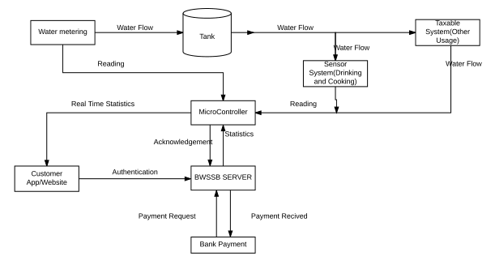

1. **Control Flow of the Proposed System**

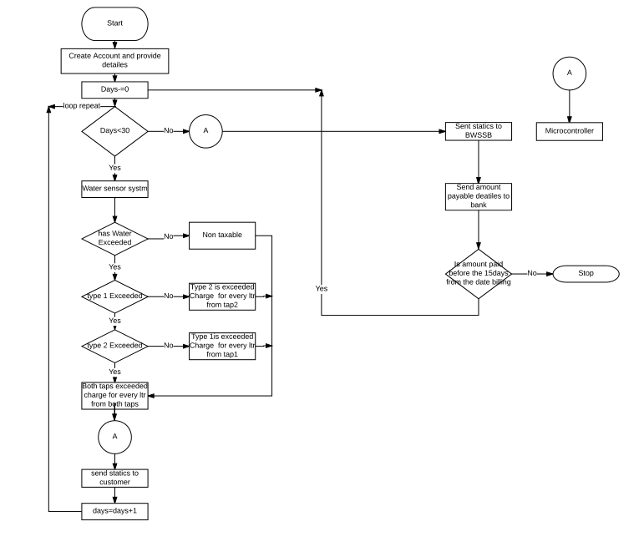

1. **Algorithm**

Start

* 1. Customer Registration
     1. Customer Information recording
  2. Login to service
     1. Username and Password Authentication
  3. View and Manage
     1. Customer can view day by day statistics

End

Start

1. Read water metering inflow value (data)

Everyday

* 1. Record water tank level
  2. Record outflow and taxable metering flows

A. Check for threshold

* 1. Taxable
  2. Nontaxable
  3. Remainder
  4. Record sensor system flows (drinking, kitchen and bathing)

1. Check for threshold
   1. Taxable
   2. Nontaxable
   3. Remainder
2. Check for inflow and outflow
   1. Check for threshold
      1. Taxable
      2. Non-taxable

End

Start

Every month

1. Statistics will be sent to BWSSB
2. Report to User
3. Report to Bank portal (Exact date mentioned by Customer)
4. AKW send to Customer

End

1. **Circuit Diagram**

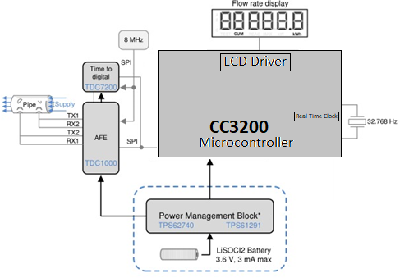

The above circuit has been borrowed from Texas Reference Design website [*].

1. **Component Used**

| TI Part Number  ( Link all the parts to their respective product page on the TI website) | How is it being used in the proposed solution? Explain its role/functionality. |
| --- | --- |
| MCC3200 - | As a microcontroller which is used in computational part |
| TDC1000 - | Water level and volume sensing |

TDC100 - <http://www.ti.com/product/TDC1000?keyMatch=tdc1000&tisearch=Search-EN-Everything>

MCC3200 - <http://www.ti.com/product/cc3220>

| Non-TI parts | How is it being used in the proposed solution? Explain its role/functionality. |
| --- | --- |
| Raspberry Pi (Optional) | If needed, used as mini Linux system to deliver real-time data 24 × 7 |
| Any other water sensors if found | To measure water volume used |

**Innovativeness of the Proposed Solution**

The average amount of water (in liters) used in house is 4 people is 18,000 liters. Let us compute the charges for this amount of water (excluding the sanitary charges and service charges) in a few metropolitan cities with its current tariff:

* In Chennai [6]: For the usage of water in the range 16-25KL in Chennai, the rate per KL is 15 ₹s.

So, the charge payable would be 18*15 = **270 ₹s**.

For 10 lakh homes in a city, the revenue generated for the water supply would be 270*10,00,000 = 27 Crores.

* In Mumbai [5]: For the usage of water irrespective of how much they consume is 3.50 ₹s per kilo liter.

So, the charge payable would be 18*3.5 = **63 ₹s**.

For 10 lakh homes in a city, the revenue generated for the water supply would be 63*10,00,000 = 6.3 Crores.

* In Bangalore [8]: For the usage of water for the amount of 18KL is **166** ₹s as calculated by the official website of Water Supply Board of Bangalore (BWSSB).

For 10 lakh homes in a city, the revenue generated for the water supply would be 166*10,00,000 = 16.6 Crores.

* In Delhi: For the usage of water in the range 0-20, the rate per kilo liter is 4.39

So, the charge payable is 18*4.39 = **79 ₹s**.

For 10 lakh homes in a city, the revenue generated for the water supply would be 79*10,00,000 = 7.9 Crores.

Since we charge more and justly without being a burden to the general public, it generates more revenue to the government which will be depicted in the next section.

**Impact of the proposed solution**

In our proposal, we charge the user with 10 ₹s per kilo liter for drinking and cooking purposes, 20 ₹s per kilo liter for toilets, bathing, washing dishes, clothes and cleaning home. The limit for drinking and cooking is 10 liters and 125 liters for the rest of the uses. Once this limit is reached, for any consumption, the price would be 50 ₹s per kilo liter.

So, let us say each individual in a house of 4 has used up their water allotted for the complete month (water without taxes).

The water used up by that home in a month is 4 individuals * 135 liters * 30 days = 16.2KL

The water used for drinking in a month is (4 individuals * 10 liters * 30 days) = 1.2 KL

Charge for this is 1.2 * 10 = **12 ₹s**.

The water used for other purposes in a month is (4 individuals * 125 liters * 30 days) = 15KL

Charge for this is 15 * 20 = **300 ₹s**.

`Total charge would be 300+12 = **312 ₹s**.

Suppose the family has used 18KL, same as the amount mentioned in the above cases, the revenue generated would be (18KL – 16.2KL) * 50 = **90 ₹s** extra.

For 10 lakh homes in a city, the revenue generated for the water supply would be

312*10,00,000 = 31.2 Crores.

|  | **Bangalore** | **Chennai** | **Mumbai** | **Delhi** | **Our Proposal** |
| --- | --- | --- | --- | --- | --- |
| **Revenue generated for using 135 liters/person/day (In Crores)** | 14.4 | 24.3 | 5.67 | 7.11 | **31.2** |
| **Revenue generated for using 18 KL/home in a month**  **(In Crores)** | 16.6 | 27 | 6.3 | 7.9 | **40.2** |

Table to represent revenue generated for a month in Crores for 10 lakh homes

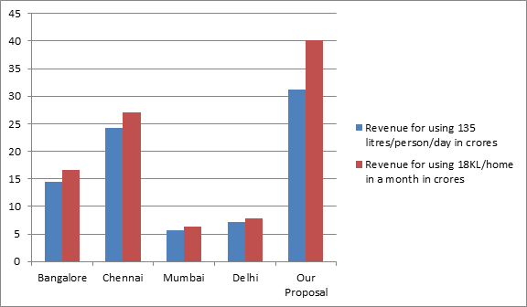

As we see from the above table, once the customer uses the water after crossing the threshold, the customer will be paying extra amount of just 30 ₹s (in this case), for using 1800 liters above the threshold value. This small difference in the amount would increase the revenue generated by the government up to 2 times (*justified by the above plot).*

Thus in the end, we would like to propose that conserving the natural resources is a crucial matter. This is our small effort in doing so with the best of our knowledge.

**References:**

1. Half of the Kaveri Water is wasted: [http://www.indiaspend.com/cover-story/bengaluru-wastes-nearly-50-water-supply-from-Kaveri-53879](http://www.indiaspend.com/cover-story/bengaluru-wastes-nearly-50-water-supply-from-cauvery-53879)
2. Need of smart water systems in India - <https://www.ripublication.com/ijaer16/ijaerv11n4_10.pdf>
3. Kaveri River Dispute - <https://en.wikipedia.org/wiki/Kaveri_River_water_dispute>
4. A R Shiva Kumar- <http://www.forbesindia.com/blog/economy-policy/bangalores-rain-catcher-the-man-who-never-payed-for-water/>
5. Mumbai Water Tariff - <http://www.bcpt.org.in/articles/watersupply.pdf>
6. Chennai Water Tariff - <http://www.chennaimetrowater.tn.nic.in/tariff.html>
7. California’s Smart Water Meters - http://www.businessinsider.com/california-is-launching-smart-water-meters-that-could-help-curb-the-water-crisis-2015-6?IR=T
8. Bangalore Water Tariff :<http://bwssb.gov.in/bwssbuat/content/tariff>]

*. TI Reference Library: <http://www.ti.com/product/cc3200?keyMatch=cc3200&tisearch=Search-EN-Everything>